
Business / Technical Brief

Design Specification

Domino-INT031 – Movement Request Integration from Fusion to WMS
28th May 2024, Version 1a.
Copyright © 2024, Oracle and/or its affiliates
Confidential – Oracle Restricted

Document Control

Change History
Date | Author | Version | Description
28-May-2024 | Amit Sharma | Draft | Initial Version
04-June-2024 | Harshada Ingole | 1.0 | Technical Design update

Reviewed By
Date | reviewer | role
04-Jun-2024 | Rakesh | Technical Lead

Table of contents
Document Control 2
Change History 2
Reviewed By 2
Introduction 4
Purpose 4
Overview and Scope 4
Business Objectives 5
Process Overview 6
Mapping 6
Pre-Conditions 6
Risk Matrix 6
Other Integrations Design Dependency 6
Frequency 7
Business Use Case: 7
Open Items 7
Technical Overview 8
Scope 8
Glossary 8
Document References 8
Sample Data & Mapping Template 8
Frequency 9
Assumptions 9
High Level Approach 9
Pre-Requisites 10
Integration Analysis - XxScmMovementRequestERPToWMS 10
Integration Components 10
Required Connections 10
Integration Outline 11
Scope Fault 18
Global Fault 19
Migration Steps 22
Unit Testing 22
Open and Closed Issues 22

Introduction

Purpose
This Design Specification documents the detailed design for Movement Request Interface from Fusion to Oracle Cloud WMS.
This document describes the functional design of the list of attributes which need to be interfaced from Fusion to Cloud WMS through Oracle Integrated Cloud Service (OIC) to create movement requests in WMS originating from min-max replenishment from Fusion Inventory Management. The design document also covers the event attribute mappings from Fusion to Oracle Cloud WMS Functional Columns.

Overview and Scope
Overview
Movement requests are requests for the movement of material within an inventory organization such as a warehouse or facility.
These types of movement requests exist:
- Replenishment movement requests
- Shop floor movement requests
Business Purpose
Movement Request transaction enables to perform the complete process required to request movement of material, physically move material, and confirm physical movement of material. Hence, a specific interface needs to be built between Fusion and Cloud WMS as per the Business Requirement to keep movement request intact between the two systems.
This design document focuses on building an interface between Fusion and Cloud WMS so that movement requests are performed without any issues.
Scope
The scope of this document is limited to functional design of the interface movement requests from Fusion to Cloud WMS System.

Functional Overview
Fusion Movement Request is a source for all movement requests published to WMS. These movement requests will be interfaced to WMS for different use cases.
- Min-Max replenishment process in Fusion will trigger a movement request in WMS to move material to PRODUKTION lineside locations from respective Storage Subinventory specified as part of Min Max Setup at Subinventory Level.
Movement Request Type; Replenishment
Transaction Type: Movement request Transfer

- Manual Movement request
Manually Created in Fusion
Movement Request Type; Replenishment
Transaction Type: Movement request Transfer

- RTV Lineside returns stock to be moved to the RTV sub inventory via the movement request.
Movement Request Type; Replenishment
Transaction Type: Movement request Transfer
From Subinventory : Shopfloor Subinventory as captured in the Lookup.
To Subinventory : RTV Subinventory in the Lookup
Details of Serial and Lot Number to be transferred are captured as part of the Movement request.
Locator in Produktion from where movement has to be executed has to be captured as part of Movement request.

The movement request in WMS should include the following details at minimum:
- Movement Request Number
- Movement Request Type
- Auto Consume Flag (Y/N)
- Item Code
- Item Quantity
- Destination Location Barcode
- Destination Location Replenishment Zone
- Movement Request Detail Custom Field 1 (Source Sub Inventory)
The integration is a BIP-based integration wherein OIC will runs the BIP report every 10 minutes and interfaces the movement requests to WMS.

Business Objectives

The following objectives were captured during the Focus Stage and are addressed by the functional designs described in this document:

Requirement ID | Category | Short description
INT031 | Movement request from Fusion to WMS | This interface will publish movement requests for Warehouse Management System (WMS) downstream systems.

Process Overview

The below picture depicts the general steps in the creation of movement requests in Fusion that will be interfaced to WMS

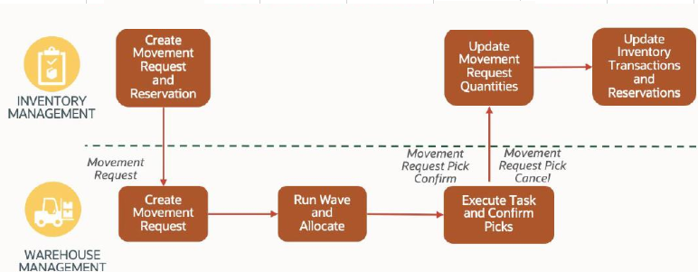

Mapping

Pre-Conditions
- Organizations against which movement requests are created should exist in WMS.
- Replenishment Templates should be configured in WMS to allocate inventory against the Movement Request.
- Movement Request types (“Replenishment” and “Pick & Move”) should be configured in WMS.
- For movement from Shop floor subinventory to RTV, Subinventories should be setup in a lookup.

Risk Matrix
Risk | Impact  (1 to 5) | Probability  (1 to 5) | Mitigation
Movement Request Interface Failure to WMS due to missing item in WMS | 5 | 2 | Valid error message stating the integration failure. Re-run the movement request integration
Movement Request Interface Failure to WMS due to missing item movement request type in WMS | 5 | 2 | Configure the movement request type in WMS and then Re-run the movement request integration

Other Integrations Design Dependency

Name | Dependency | comments
INT001: Item Interface to WMS |  | Items against which the movement request is created should exist in WMS

Frequency
Responsiveness | Frequency | Comments
XxScmMovementRequestERPToWMS | OIC runs BIP report every 10 min

Business Use Case:
- Create movement request for a serial controlled item.
- Create movement request for a batch/lot-controlled item.
- Create a movement request for a non-inventory item.
- Create a movement request for inventory movement from lineside to the RTV location.
- Create movement request for a revision controlled Item

Open Items
This section is used to summarize any open items related to the design.
No. | open item | data required/Owner | status | impact if not closed
001 | Serial number reservation against a movement request | OC | Feature to be released in release 24B
002
003
004
005
006
007

Technical Overview

Scope
The objective of this document is to provide Domino Printing with a Technical Specification for Outbound Integration to extract the Purchase Order Data from SCM Cloud and publish to WMS Cloud.

Glossary
Annotation | Definition
ERP | Enterprise Resource Planning
SCM | Supply Chain Management
OIC | Oracle integration cloud
API | Application Programming Interface
WMS | Warehouse Management System
REST | Representational State Transfer
XSD | XML Schema Definition
FYI | For Your Information

Document References
Ref No | Name | File location
1
2
3

Sample Data & Mapping Template

Description | File
Data Mapping Template for Fusion to WMS
Sample WMS XML Payload

Frequency
Responsiveness | Frequency | Volume
 | Daily- every 5 minutes | Depends on the volume of min max replenishment movement requests created

Assumptions
- Mapping between Movement Requests in SCM Cloud and WMS Facilities needs to be setup for this integration to extract data.
- The integration includes the possibility to CREATE the Movement Request from WMS Cloud. It only covers create operation.
- In case of any success/error in the integration, a notification email will be sent to the mail list configured in the OIC lookup.
- Min Max replenishment movement requests are only to be considered.
- The integration will be scheduled every 5 minutes a day.

High Level Approach
- Integration is scheduled to run every 5 minutes a day daily and picks up all the min max replenishment type movement requests that are pending to be interfaced to WMS using BIP report.
- The BIP report output will be then converted into WMS XML required format by invoking the Rest API echoLgfDataOrder which will do the XML transformation internally.
- The transformed XML data will be interfaced to WMS cloud using WMS InitStageInterfaceAPI service.

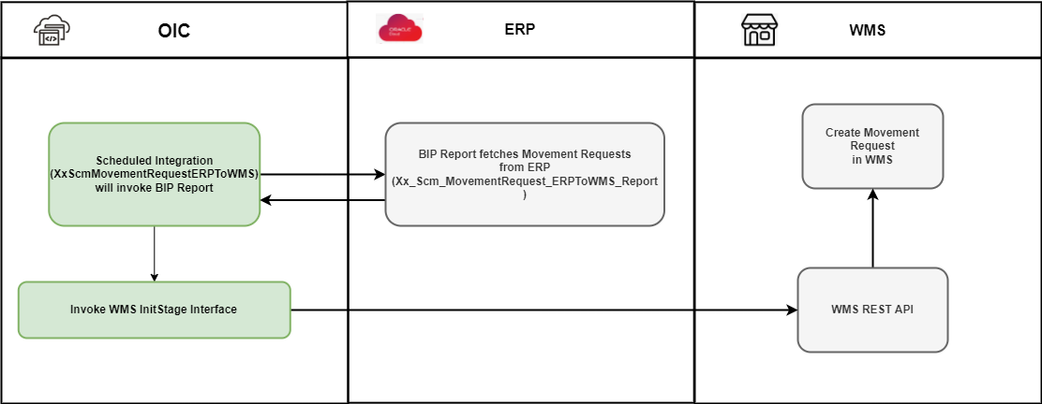

Pre-Requisites
- Send email and SMS integration “XxCommonNotificationHandler” should be deployed in the OIC.
- “XxGetLookupVariable” integration should be deployed in the OIC.
- Lookup “XXDominoCommonLookup” should be present with all the required details regarding success/error email notify flag, success and error notify ErrNotifyEmail Address in OIC.
- Lookup “XxDominoConstantLookup” should be present with all the required details regarding success and error notify FromEmail Address in OIC.

Integration Analysis - XxScmMovementRequestERPToWMS
This Integration component is responsible for for mapping Movement requests from ERP Cloud to WMS Movement requests.

Integration Components
Below are the required components for this integration.

Integration Name | Integration Pattern | Package Name | Lookup Name
XxScmMovementRequestERPToWMS | Scheduled Integration |  | XXDominoCommonLookup  XxDominoConstantLookup

Required Connections
Connection Name | Connection Type | Connection Role
XxDominoErpCloudConnection | Oracle ERP Cloud | Trigger and invoke
XxDominoWMSConnection | REST | Trigger and invoke
XxDominoBIReportConnection | SOAP | Invoke

Integration Outline
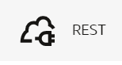
Fusion responds to OIC Integration with the BIP report output.
WMS-XML Transmission Integration

Invoke Rest API Integration to Perform the mapping for ERP Payload and Convert into WMS Required Request Format
OIC
Integration
XxScmRTVErpToWMS
Invoke the WMS init stage API Endpoint to load the data into WMS cloud.
Corresponding status of file records (Success/Error) will be sent back by WMS API to OIC.

OIC Integration will run every 5 minutes daily and invoke BIP report in Oracle fusion.
Figure 1: Architecture Diagram

The Following section explains the step – by- step process of publishing Purchase Orders from Fusion to WMS:

Integration – XxScmMovementRequestERPToWMS
- This is a scheduled orchestration integration which will run every five minutes daily.
- AssignGlobalVariable: The Global variable will be the Integration code which will be fetched from maintained lookup –“XXDominoCommonLookup” with the reference of this lookup all other local variables will fetched which are given below.
- Variable name | Data type | Value
IntegrationCode | String | dvm:lookupValue('XXDominoCommonLookup','IntegrationCode', ' XXSCMRECEIPTADVICEERPTOWMS, 'IntegrationCode', '')  IntegrationCode will be fetched from OIC lookup “XXDominoCommonLookup”, with reference to this lookup all other local variables will be fetched.  Value for IntegrationCode variable is Integration identifier.
var_invokeLgfIntegError | String | ‘’
var_ErrorFlag | String | 'N'
var_ErrorCode | String | ‘’
var_ErrorMsg | String | ‘’

- FetchVariable: This step will invoke integration ‘XxGetLookupVariable(1.0)’.
Map Activity FetchVariable: In this Map activity, ‘Integration Name’ received from Integration Metadata will be mapped to ‘Integration Code’ in Fetch Variable (request). Once ‘Integration Code’ gets passed to ‘XxGetLookupVariable(1.0)’ integration, values of variables can be retrieved.
- InitAtp: This step is used to insert data in XXDOM_INT_INSTANCE_DETAILS_T table in autonomous database.
Map Activity InitAtp: This Map Activity inserts data in XXDOM_INT_INSTANCE_DETAILS_T table.
Request Parameters | Values
instanceId | $self/nsmpr1:metadata/nsmpr1:runtime/nsmpr1:instanceId
integrationName | $self/nsmpr1:metadata/nsmpr1:integration/nsmpr1:name
riceId | $FetchVariable/nsmpr0:GETResponse/nsmpr0:components.schemas.response-wrapper/ns35:RiceID
createdBy | $self/nsmpr1:metadata/nsmpr1:runtime/nsmpr1:invokedBy
status | 'Init'
attribute1 | $tracking_var_1
attribute2 | $tracking_var_2
attribute3 | $tracking_var_3

- SetUpVariables:
Below variables have been defined in this step:
Variable name | Data type | Value
CurrentPotentialError | String | 'Error while invoking LgfData integration.'
EmailFrom | String | dvm:lookupValue('XxDominoConstantLookup', 'ID', 'FromEmailId', 'Value', '')
InstanceName | String | dvm:lookupValue('XxDominoConstantLookup', 'ID', 'InstanceName', 'ID', '')
CompanyCode | String | dvm:lookupValue('XXDominoWmsCompanyLookup', 'Organization', /ns12:onEvent/ns18:getReceiptAdviceDetailsResponse/ns18:ReceiptAdvice/ns22:OrganizationCode, 'WMS_Company_Code', '')
ParentCompanyCode | String | dvm:lookupValue('XXDominoWmsCompanyLookup', 'Organization', /ns285:onEvent/ns291:getReceiptAdviceDetailsResponse/ns291:ReceiptAdvice/ns295:OrganizationCode, 'WMS_Company_Code', '')
p_vendor_name | String | ‘’
p_supplier_site_code | String | ‘’

- IntegrationScope: scope_updateMovemementReqToWMS
- Invoke BIP Report to fetch the Min max replenishment movement requests which are not interfaced to WMS.
- Read the BIP report
- If count of movement request in the BIP Report is greater than 0, then
  - Convert the payload received from fusion ERP to WMS Request format. It is internal XML transmission. Response of this API will be sent to WMS as input parameters.
  - postInitStageInterfacePO: This step will call the WMS common api- “/wms/api/init_stage_interface/” which is responsible to post the data on into WMS system. In case of any error while calling this API, notification will be sent through common error handler integration to respective team. There are three query parameters for added for this API to send the request as below:
- Query Parameters-
    - Async – This will be set to value as “False”.
    - Validate_xml – This will be to set to value to “True”
    - Entity- purchase_order
    - Xml_data- This will be mapped with the response of echoLgfDataOrder which will send the data as parameter to WMS API to post the data in WMS side.
The request will be sent to WMS API as – Send query parameters as form data in message body.
Once the data is successfully loaded into WMS side, WMS API will send consolidated response for all records in payload back to OIC, in case of any error while posting the data to WMS same will be captured by WMS API and will be send to OIC.
  - SuccessNotify: Once the data is posted into WMS side and all the operations in Integration are completed normal then success email notification will be sent to respective team through “XxCommonNotificationHandler(1.0.1)”.
With map activity, process will map the below values to common error handler Integration.
Request Parameters | Values
IntegrationCode | $self/nsmpr3:metadata/nsmpr3:integration/nsmpr3:name
IntegrationID | $FetchVariable/nsmpr1:GETResponse/nsmpr1:components.schemas.response-wrapper/ns38:RiceID
InstanceID | $self/nsmpr3:metadata/nsmpr3:runtime/nsmpr3:instanceId
ErrorCode | NULL
ErrMsg | NULL
EmailFrom | $EmailFrom
EmailTo | $FetchVariable/nsmpr1:GETResponse/nsmpr1:components.schemas.response-wrapper/ns38:SuccessNotify
EmailSub | concat ("FYI", ":", "SUCCESS", ":", $self/nsmpr3:metadata/nsmpr3:integration/nsmpr3:name, "(", $self/nsmpr3:metadata/nsmpr3:integration/nsmpr3:version, ")", ":", $self/nsmpr3:metadata/nsmpr3:runtime/nsmpr3:instanceId )
Logging

WMS Request and Response Schemas:

WMS Request Schema
WMS Response Schema

Sample WMS Response:
WMS Response | Response Message
SUCCESS-True | <executeResponse xmlns="http://xmlns.oracle.com/cloud/adapter/REST/postInitStageInterfacePO_REQUEST/types">  <root xmlns="http://xmlns.oracle.com/cloud/adapter/nxsd/surrogate/response/postInitStageInterfacePO/">  <success>True</success>  <response>  <message>Stage table processing complete</message>  </response>  </root>  <HTTPHeaders/>  <ConnectivityProperties xmlns="http://xmlns.oracle.com/cloud/adapter/connectivityproperties/REST/postInitStageInterfacePO_REQUEST/RESTOUTRES">  <RestAPI>  <http.response.status>200</http.response.status>  <http.response.reason>OK</http.response.reason>  <http.target.endpoint.uri>https://tb10.wms.ocs.oraclecloud.com/domino_test/wms/api/init_stage_interface/</http.target.endpoint.uri>  </RestAPI>  </ConnectivityProperties>  </executeResponse>
Success-False | http://www.w3.org/Protocols/rfc2616/rfc2616-sec10.html#sec10.4.1  Bad Request  400  <![CDATA[InboundJaxrsResponse{context=ClientResponse{method=POST, uri=https://tb10.wms.ocs.oraclecloud.com/domino_test/wms/api/init_stage_interface/, status=400, reason=Bad Request}}]]>  <![CDATA[<?xml version="1.0" encoding="utf-8"?>  <root>  <success>False</success>  <response>  <message>Processing failed for entity movement_request and file group 2023-04-18T09:35:22.895Z_20230418053524195</message>  <errors>  <error>  <key>191</key>  <msg>Sequence Number Mismatch for item alternate code EPP003436</msg>  </error>  </errors>  </response>  </root>.  A 400 Bad Request Error indicates that the target service is unable (or refuses) to process the request sent by the client (Oracle Integration Cloud), due to an issue that is perceived by the server to be a client problem. You can trace the cURL representation of the request sent to the target service from the Oracle Integration Cloud server logs. Try invoking the target service using cURL. It may also be that one of the intermediaries (proxy, LBR) could be returning this code. ]]>

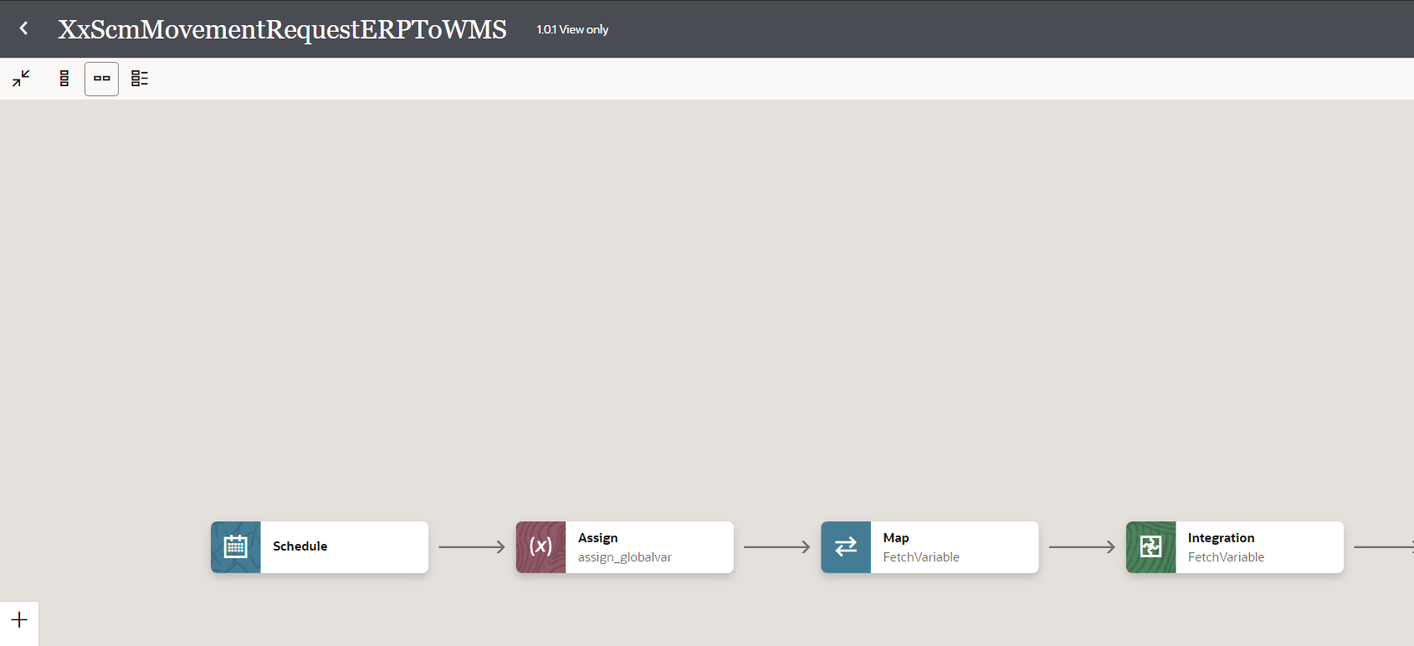

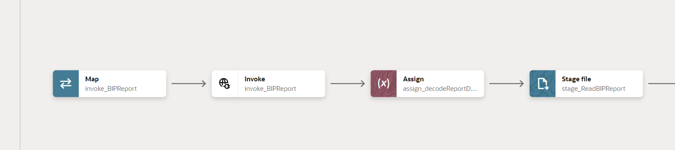
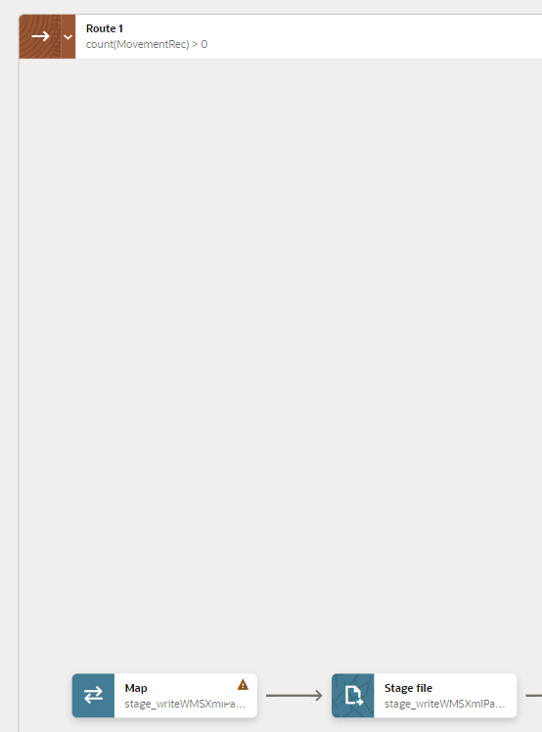
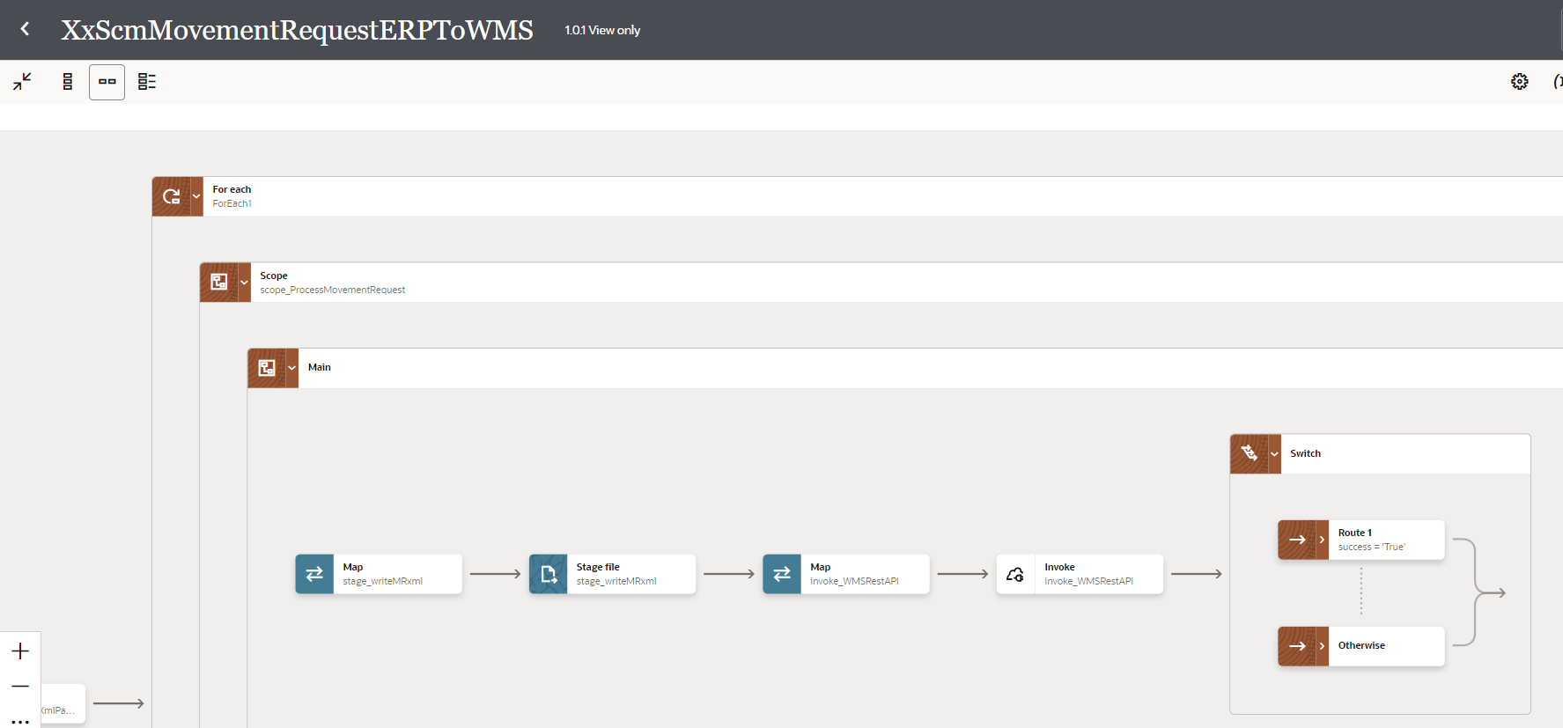
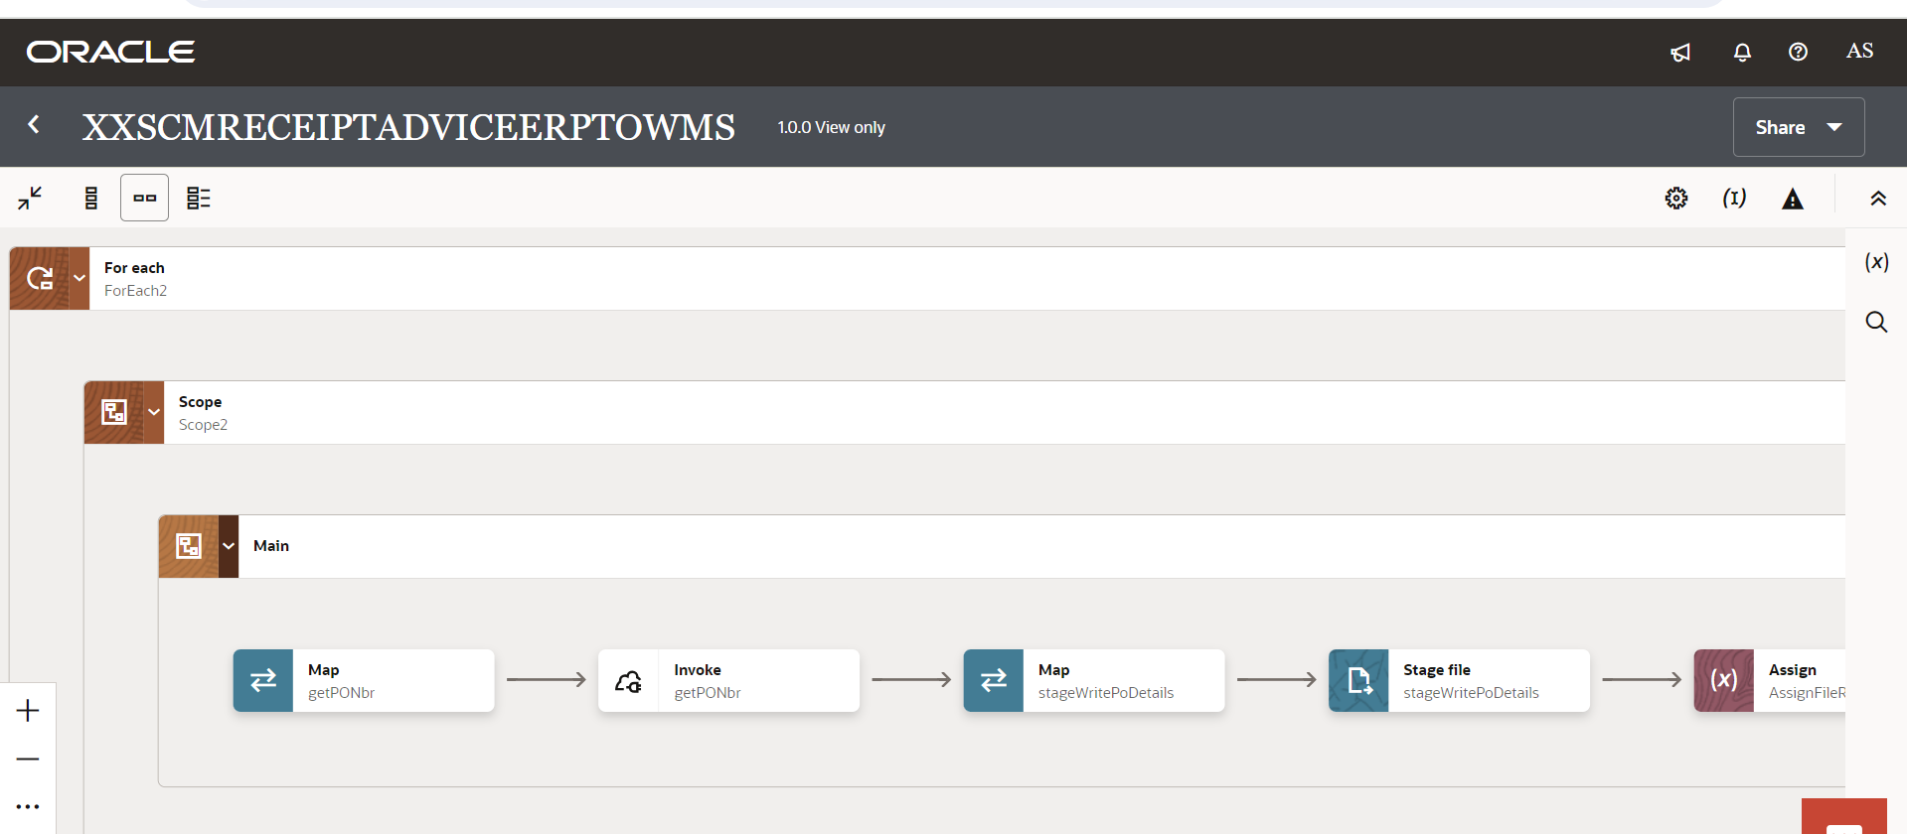

Figure 2 : Main flow code snippet

Scope Fault
- InvokeCommonErrorHandler:
- In fault handler section, process will call “XxCommonNotificationHandler” local integration which will capture the errors occurred in APIs invocation process, or any error in any integration operation, will be handled in scope fault handler and Email Notification will be sent to concerned team.
- With map activity, process will map the below values to common error handler Integration.
Request Parameters | Values
IntegrationCode | $FetchVariable/nsmpr0:GETResponse/nsmpr0:components.schemas.response-wrapper/ns37:IntegrationCode
IntegrationID | $FetchVariable/nsmpr0:GETResponse/nsmpr0:components.schemas.response-wrapper/ns37:RiceID
InstanceID | $self/nsmpr3:metadata/nsmpr3:runtime/nsmpr3:instanceId
ErrorCode | $IntegrationScopeFaultObject/nsmpr2:fault/nsmpr2:errorCode
ErrMsg | $IntegrationScopeFaultObject/nsmpr2:fault/nsmpr2:reason
EmailFrom | $EmailFrom
EmailTo | $FetchVariable/nsmpr0:GETResponse/nsmpr0:components.schemas.response-wrapper/ns37:FailureNotify
EmailSub | concat ($InstanceName, ":", "FYI", ":", "ERROR", ":", $self/nsmpr3:metadata/nsmpr3:integration/nsmpr3:name, "(", $self/nsmpr3:metadata/nsmpr3:integration/nsmpr3:version, ")", ":", $self/nsmpr3:metadata/nsmpr3:runtime/nsmpr3:instanceId )
Logging

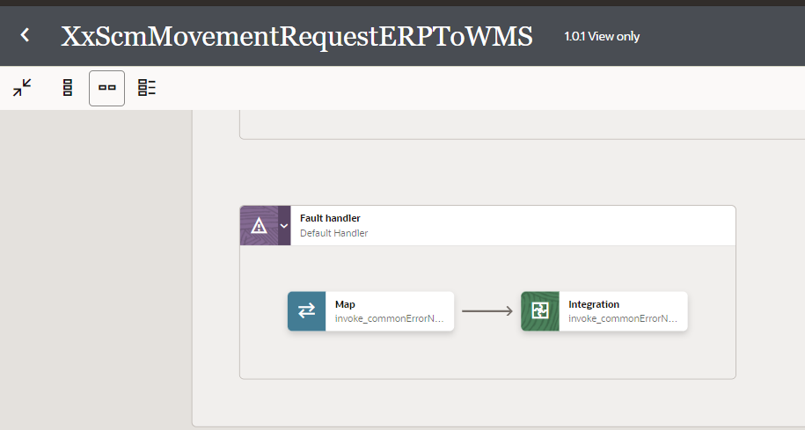
Figure 4: Scope Fault code snippet

Global Fault
The global fault handler is responsible for the whole execution scope and processes the exceptions occurred in the individual stages.
- AssignGlobalVariables: The Global variable will be “Integration Code” which will be fetched from lookup “XXDominoCommonLookup” maintained in OIC. With the reference of this lookup, all other Error variables will be fetched which is listed below-
Variable name | Data type | Value
IntegrationCode | String | lookupValue('XXDominoCommonLookup', 'IntegrationCode', 'XXPUBLISHSUPPLIERERPTOGTMCALLBAC', 'IntegrationCode', '')  IntegrationCode will be fetched from OIC lookup “XXDominoCommonLookup”, with reference to this lookup all other local variables will be fetched.  Value for IntegrationCode variable is Integration identifier.

- AssignErrorVar:
  - Using assign activity, variables will be declared to map the values required for invoking common error handler integration.
Variable | Values
IntegrationID | dvm:lookupValue('XXDominoCommonLookup','IntegrationCode', $IntegrationCode, 'RiceID', '')  This value will be fetched from common lookup “XXDominoCommonLookup” maintained in OIC, with reference of integration code value from Global variable.
EmailTo | dvm:lookupValue('XXDominoCommonLookup','IntegrationCode', $IntegrationCode, 'FailureNotify', '')  This value will be fetched from common lookup “XXDominoCommonLookup” maintained in OIC, with reference of integration code value from Global variable. It will be failure notify email id.
InstanceName | dvm:lookupValue('XxDominoConstantLookup', 'ID', 'InstanceName', 'Value', '')  This value will be fetched from constant lookup “XxDominoConstantLookup” maintained in OIC.
EmailFrom | dvm:lookupValue('XxDominoConstantLookup', 'ID', 'FromEmailId', 'Value', '')  This value will be fetched from constant lookup “XxDominoConstantLookup” maintained in OIC.

- LogGlobalFault: The logger will log Error Code, Error Reason, Error Details as mentioned below:
concat("Global fault handler caught the following error: ", $GlobalFaultObject/nsmpr11:fault/nsmpr11:errorCode, " - ", $GlobalFaultObject/nsmpr11:fault/nsmpr11:reason, " - ", $GlobalFaultObject/nsmpr11:fault/nsmpr11:details)
- CallErrorHandler:
  - The global fault handler will invoke the local integration “XxCommonNotificationHandler” which captures the error occurred at any step in overall integration flow and notify it over email.
  - Using the map activity “Map to CallErrorHandler”, process would map the below required values for XxCommonNotificationHandler.
Request Parameters | Values
IntegrationCode | $IntegrationCode
IntegrationID | $IntegrationId
InstanceID | $self/nsmpr2:metadata/nsmpr2:runtime/nsmpr2:instanceId
ErrCode | $GlobalFaultObject/nsmpr0:fault/nsmpr0:errorCode
EmailFrom | $EmailFrom
EmailTo | $ErrNotifyEmail
EmailSub | concat ($InstanceName, ":", "FYI", ":", "ERROR", ":", $self/nsmpr2:metadata/nsmpr2:integration/nsmpr2:name, "(", $self/nsmpr2:metadata/nsmpr2:integration/nsmpr2:version, ")", ":", $self/nsmpr2:metadata/nsmpr2:runtime/nsmpr2:instanceId )
Logging

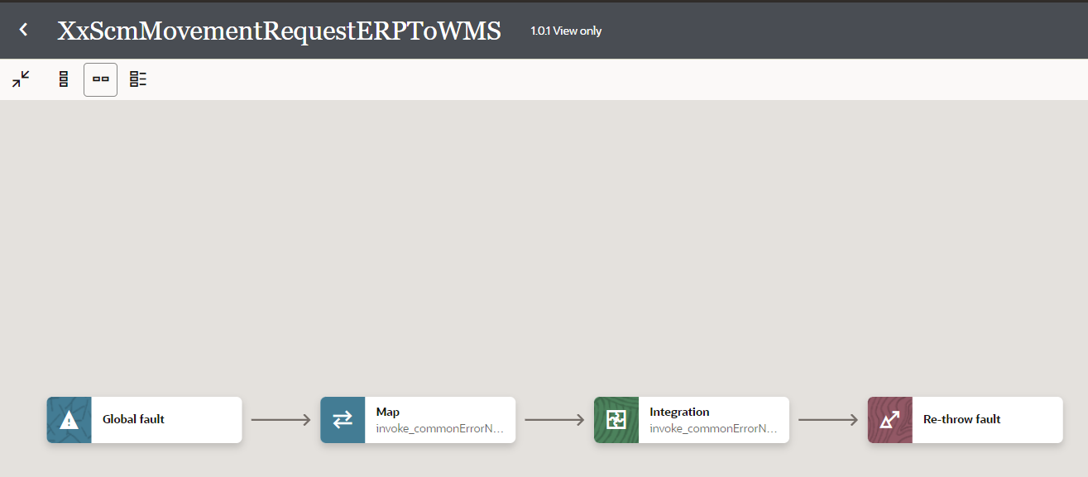
Figure 4: Global Fault code snippet

Migration Steps
2

- Import “XXSCMMOVEMENTREQ_WITHERR_01.00.0001.iar” in OIC environment.
- Update the OIC Connections with Password, details as per the Environment.
- Validate the "XxCommonNotificationHandler" is deployed in OIC.
- Update the values of Instance URl, Insatnce Name in Domino Constant lookup.
- Configure the Connection with Dev Instance URL, Instance Name (whenever updated) which is present in Domino Constant lookup maintained in OIC.
- Complete the OIC integration configuration and activate OIC service.

Unit Testing
2
4
3

Please refer the attached file for the Unit Test cases performed for this integration.

Open and Closed Issues
This section is used to summarise any open and closed questions relating to Error Handler

ID | Topic | Description | Status | Owner
1 | None
2.

